Node n=new Node;

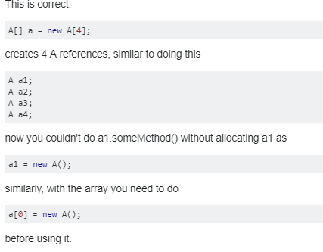

Here object is –new A();

REFRENCE MEANS-here n is refrence;

Object and Class in Java->

Object in java->

*an that has state and behavior is known as an object.exm->chair ,men;

*an object has three characteristics->

1.state->represent data value.

2. **behavior:** represents the behavior (functionality) of an object such as deposit, withdraw etc.

3. **identity:** Object identity is typically implemented via a unique ID. The value of the ID is not visible to the external user. But, it is used internally by the JVM to identify each object uniquely.

For Example: Pen is an object. Its name is Reynolds, color is white etc. known as its state. It is used to write, so writing is its behavior.

*Object is an instance of class->class is a tamplete or blueprint from which objects are created.

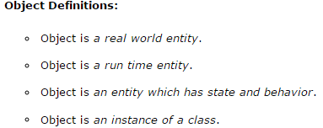

Class in java ->

*A class is a group of objects which have common properties.

* It is a template or blueprint from which objects are created.

* It is a logical entity. It can't be physical.

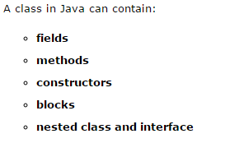

*Because **Java** is a garbage collected language you cannot predict when (or even if) an object will be destroyed. Hence **there** is no direct equivalent of a **destructor** but this is called entirely at the

discretion of the garbage collector.

How to define a class->

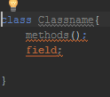

Instance of class->

* A variable which is define under the class and outside to the method.
* Instance memory doesn’t get memory in compile time.
* It gets memory at run time when object(instance) is created. That is why, it is known as instance variable.

Methods in Java->in java a method is a behavior of a Class.

*code reusability ,code optimization.

“new“ keyword in Java->

The new keyword is used to allocate memory at run time. All objects get memory in Heap memory area.

Object and class example->

A program we creat the object and then use sevral methods on class.

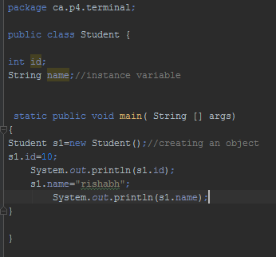

Object and class outside the class->

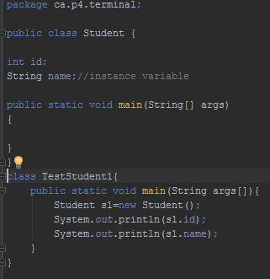

## **Ways to initialize object->**

1. By reference variable
2. By method
3. By constructor

1.by reference ->

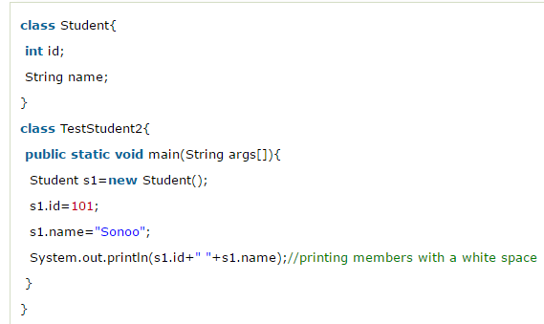

2.by method->

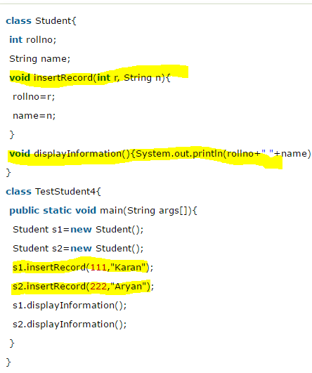

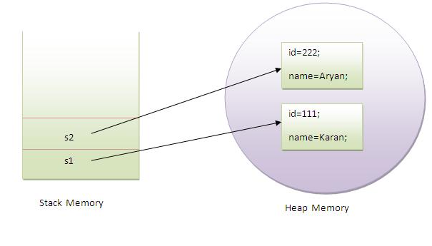

3.do later;

Example of class and object->

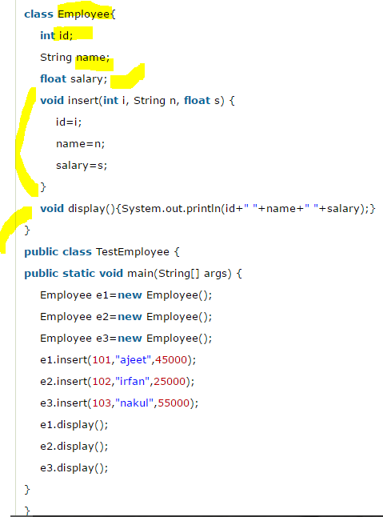

## **Anonymous object->**

## **Anonymous simply means nameless. An object which has no reference is known as anonymous object. It can be used at the time of object creation only.**

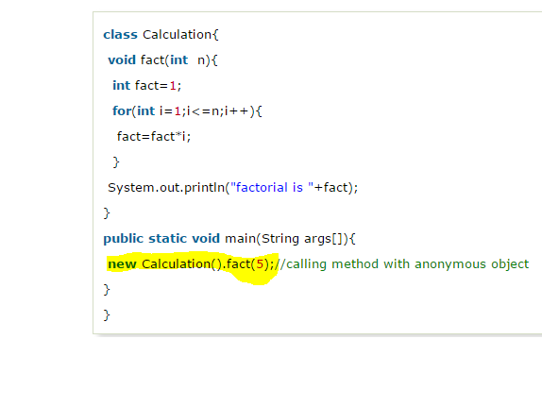

s